**Sportboat Cup 2021**

**At arrival: first check in at the Crane “4” for a launch time slot**

1 Yacht club EWVA (Registration office)

2 Regatta information display (next to the stairs of EWVA yachtclub )

3 Slipway

4 Crane (Contact point upon arrival)

5 Toilet building (toilets and showers), Supermarket and Sail repair workshop

6 Trailer parking

7 Overnight and daytime berthing

8 Yacht appliances shop

9 Location for skippers meeting, dock party and BBQ (good weather)

10 Harbor master office

**Route to Compagnieshaven Enkhuizen**

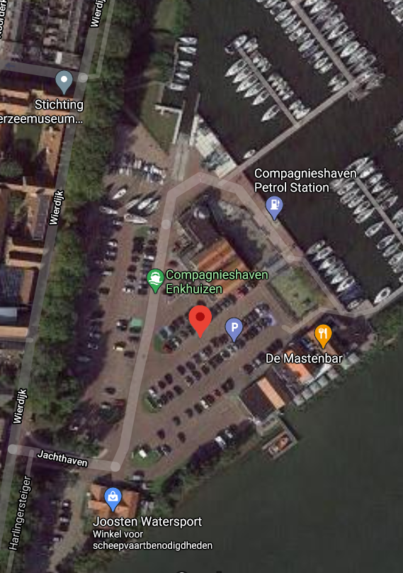Addendum A The map of the Event Venue

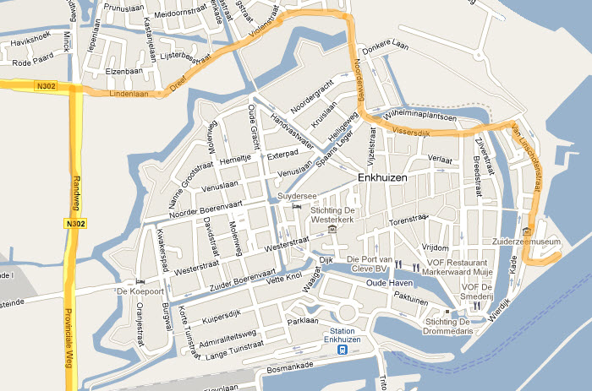

Map 1

**8**

**7**

**4**

**3**

**5**

**2**

**1**

**100**

**9**

**6**